LOGO DESIGN QUESTIONNAIRE:

There are certain questions we like to ask a client prior to beginning the logo design process, to ensure good, clear communication. It may seem like a long list but it helps us get to know what you, our client, needs and expects from your finished logo/branding. It also helps to clarify your own vision for your business branding. Please fill in this questionnaire to the best of your ability:

YOUR BUSINESS

What is the name of your business?

Describe in one sentence your business/service

What do you want your new logo to achieve?

Who are your potential clients?

YOUR LOGO

Do you have a specific idea in mind for your logo?

Do you want to use existing brand colours or a particular range of colours?

_______________________________________________________________

Are there any colors that you do not want to use?

_______________________________________________________________

Do you have a particular font you would like to use – or ones you definitely do not want to use?

_______________________________________________________________

What words should describe your logo?

What message or emotion do you want your logo to portray?

_______________________________________________________________

Does your logo have a tag line?

_______________________________________________________________

Is your tag line to appear with your logo on all of your branding?
_______________________________________________________________

What logos do you like and why?

Types of logos:
Logotype
This format includes your company’s name in stylized typeface and/or your company initials in a simple shape.
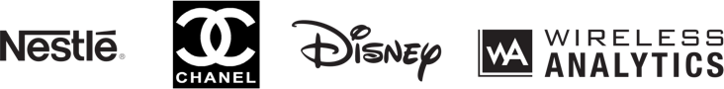

Pictorial Mark
This mark includes literal or representative imagery to symbolize your brand.
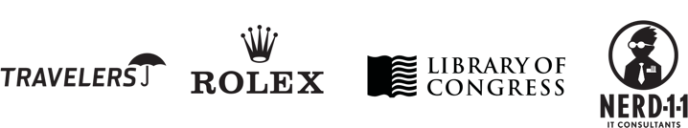

Abstract Mark
This format includes abstract shapes and symbols that convey a specific idea or attribute. These types of logos are very unique and identifiable often without the company name.
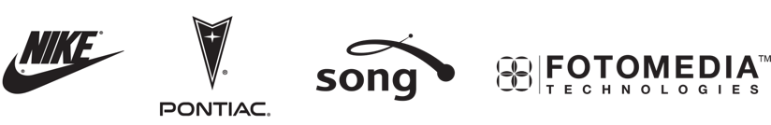

Emblem or Enclosure
This features the name or initials of the company, usually as part of a pictorial element or shape.
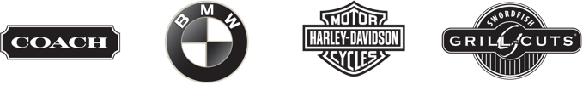

Which one of these logo styles do you feel best represents your brand?

THE PRACTICAL BITS!

What do you want your logo to be web/print-ready?

What is your Budget?

Would you like any additional design services alongside your new logo? (eg. business cards, letterheads & other stationery, social media icons/banners, advertising material etc.)

_______________________________________________________________

Any other comments?

_______________________________________________________________

